Screenshot 1 to the visualization

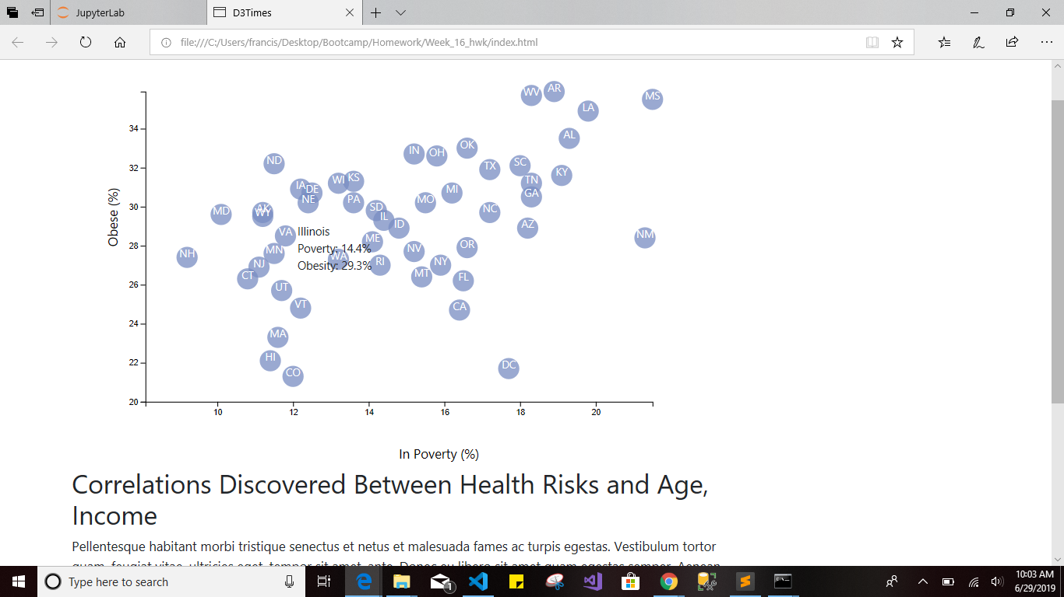

Screenshot 2



Screenshot 3

